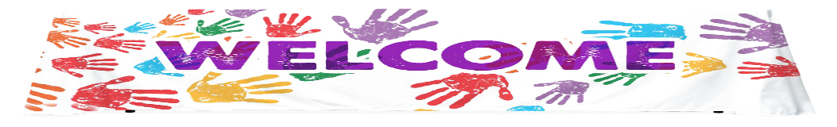

[This Photo](https://pngimg.com/download/84657) by Unknown Author is licensed under [CC BY-NC](https://creativecommons.org/licenses/by-nc/3.0/)

2023-2024

**Dear Team Bobrownicki 6th Grader,**

Welcome to SIXTH GRADE! My name is Mrs. Bobrownicki, and I would like to welcome you to sixth grade. I am so happy to have YOU in my class! I am very excited about all the wonderful and exciting things we will be learning this year! I can’t wait to get started on our path of learning together! Sixth grade is a great opportunity to discover new friends, celebrate old friends, and challenge yourself to new heights. It is going to be a very special year! I am very excited about all the wonderful and exciting things we will be learning this upcoming school year!

Sixth grade is a very special grade, and you will have many things to look forward to this coming year. We will focus on developing a wide range of reading skills and strategies through the use of quality literature. You will have many writing opportunities and will participate in a variety of hands–on math activities. Additionally, you will be learning about Ancient Egypt, The Human Body, Pollution, Earth’s Changing Surface to name a few of our exciting units. You all will be able to participate in some wonderful activities that are special to **6th graders only** such as our 6th grade ropes course field trip, being a host on Butler Live, becoming a safety and taking part in student council.

It is my hope that this year we will form a partnership to make your last year at Butler productive and fun! Part of enjoying your classroom community is getting to know your teacher. So, here is a little bit about me. I am looking forward to a wonderful summer with my family and friends. I am married with three children, Hannah and Emily who are 20 and are juniors in college at Penn State University and Elizabethtown College. I also have a son named Philip who is 12 years old and will be going into 7th grade at Unami Middle School this year. This summer, I will be traveling to Myrtle Beach, South Carolina and Cooperstown, New York with my family. We will spend our days on the beach, golfing, watching my son play baseball and visiting relatives. I have a dog named Bentley who is 7 years old and loves to eat peanut butter and carrots. In my spare time I enjoy making jewelry, reading, and cooking delicious foods. I look forward to hearing all about you and all the wonderful things you have enjoyed this summer during the first week of school!

On my teacher site you will find our class supply list with all the materials you need to start your year off on the right foot. Please make sure you have all the necessary materials on the first day of school so we can get ourselves organized and dive right into the new school year. Also, make sure to bring in a quiet reading book the first day of school and a delicious snack.   In addition, please bring in a special treasure of something that you did over the summer (it doesn’t have to be anything fancy). We will share our special items on the first day!

Here are a few things that I know will help you have a great sixth grade year!

1. Be organized and have good work habits.
2. Always be prepared with your homework.
3. Don’t be afraid to ask questions.
4. Always try your best and have a positive attitude.
5. Treat others, as you would want to be treated.
6. Stretch out your comfort zone and try new things.

If you remember these six things, you will have a very successful year. If you need to reach me my email is [Jbobrown@cbsd.org](mailto:Jbobrown@cbsd.org). Enjoy the rest of your summer vacation and see you on the first day of school!

Sincerely,

Mrs. Bobrownicki